**ND SPF – PFS**

**Grantee Training #4**

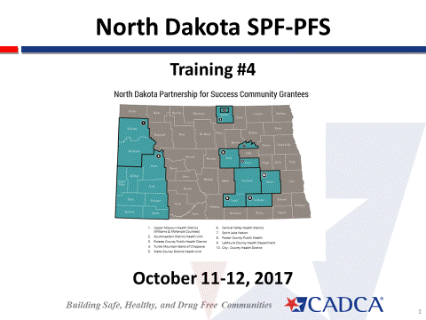

**October 11 – 12, 2017**

**Participant Workbook**

**Timeline**



**Rx Drug Abuse Work Group Job Description**

**Coalition Member Job Description**

The Rx Drug Abuse Work Group operates as an “ad hoc” work group of the ABC Coalition. Members of the Rx Drug Abuse Work Group will work together to develop and implement comprehensive plans to address the Rx Drug Abuse problem in ABC County. The Rx Drug Abuse Work Group is composed of 5 – 10 individuals from the community interested in addressing the Rx Drug Abuse issue. Specific sectors will be recruited to the Rx Drug Abuse Work Group including: youth, parents, law enforcement, health care providers, education, treatment providers, government, faith community, recovery community, and others.

**Time Commitment**

Members of the Rx Drug Abuse Work Group are asked to work together from April – September, 2012. The Rx Drug Abuse Work Group will schedule meetings on an “as needed” basis depending on the specific tasks to be accomplished. It is anticipated that the Rx Drug Abuse Work Group will meet at least once per month, or six times over the six month period.

**Specific Responsibilities**

* Attend Rx Drug Abuse Work Group meetings.
* Participate in the planning process including assessment, planning, implementing and evaluation of prevention strategies.
* If appropriate, represent their organization and sector in the Rx Drug Abuse Work Group’s activities.
* As appropriate, provide specific resources to support the Rx Drug Abuse Work Group’s efforts.
* Engage and recruit community members to participate in the Work Group’s efforts

**Personal Qualities**

* Commitment to improving the health of ABC County residents
* Knowledge of the ABC County area and its people
* Broad perspective in identifying and planning programs
* Enthusiasm and resourcefulness

**Serving as a member of the coalition will provide you with the opportunities to:**

* Broaden your knowledge of Rx Drug Abuse prevention strategies
* Gain new experiences and skills
* Increase communication skills while conducting outreach with coalition & community members
* Network with “like-minded” individuals in the community
* Participate in creating a “safe and healthy” community in ABC County

**For more information, please contact Pat Grimsley, Rx Drug Abuse Work Group Chair at patg@abc.org**

**Adapted from:** [**http://www.health.state.mn.us/divs/hpcd/chp/hpkit/pdf/build_samp1.PDF**](http://www.health.state.mn.us/divs/hpcd/chp/hpkit/pdf/build_samp1.PDF)

|  |  |  |  |  |
| --- | --- | --- | --- | --- |
|  | **Goals /Tasks** | **Strategy(s)** | **WIFM** | **Contact** |
| **Parents** |  |  |  |  |
| **Faith Community** |  |  |  |  |
| **Youth** |  |  |  |  |
| **Civic Groups** |  |  |  |  |
| **Other:** |  |  |  |  |

## Targeting Specific Sectors

**Clarify Priority Local Condition and Evidence-based Policy**

Describe the local condition with as much detail as you can. Be sure to include: what is the behavior, where does it occur, when does it occur, who is involved, what is the environment in which the behavior occurs:

What evidence-based policy that you have identified that will address the local condition?

## Policy Action Statement

Choose a local condition from your logic model for which you would like to develop a policy strategy. In 25 words or less, create your policy action statement. Be sure to include:

* + The local condition to be addressed
  + A specific policy solution
  + What the policy will do
  + What are benefits of the policy
  + The decision makers who can make the policy change happen

## 

## 

Page 1

Page 4

## 

Page 3

Page 2





**Power Analysis**

Use the following table to begin the power analysis about how decisions are made in your community and how to engage the decision makers. Be prepared to share your responses with the large group.

|  |  |  |  |  |
| --- | --- | --- | --- | --- |
| Who are the most important individuals? | With whom must you speak before approaching him/her? | What is his/her self-interest? | If an elected official, how will you influence him/her? | Who should approach this person? |
|  |  |  |  |  |
|  |  |  |  |  |
|  |  |  |  |  |
|  |  |  |  |  |
|  |  |  |  |  |